CUB SCOUT
LEADER TRAINING

IN-PERSON TRAINING
Position-Specific In-Person Training Guides Available Now! The training guides for
- Den Leader (http://www.scouting.org/filestore/training/pdf/515-215.pdf ),
- Cubmaster/Assistant Cubmaster (http://www.scouting.org/filestore/training/pdf/511-503_WB.pdf ), and
- Pack Committee (http://www.scouting.org/filestore/training/pdf/511-504_WB.pdf )

Are available on Scouting University. You can access them at http://www.scouting.org/training/adult.aspx .
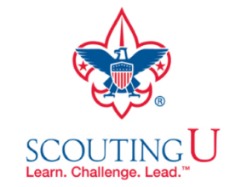

ON-LINE TRAINING
On-Line Training for all Cub Scout positions has been available since October 25, 2015
The online training for Den Leaders, Cubmasters, Committee Chairs and members, and Chartered Organization Representatives is totally updated with help from volunteers from around the country. The new training is divided into shorter, more targeted modules so leaders can get the training they need, in the order they want, any time they need it. It is organized around the learning needed prior to the first meeting, in the first 30 days, and to be position-specific trained. This training was developed to be implemented in conjunction with the BSA’s new learning management system. Keep an eye on
my. Scouting Tools (log in at https://My.Scouting.org) for more information.
Go to the BSA Volunteer Training Team Facebook page (Link above) and.
Then you automatically receive the latest news!!
If you are having difficulties with
the training or system call
BSA Member Care at 972-580-2489
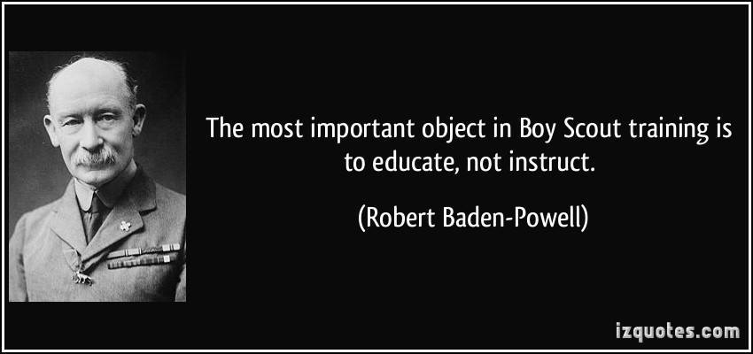
A Typical Learning Plan has several parts –
There is no need to complete more than one section at a time. Do what you have time to do.
Here you can see the three parts of the CM Course -
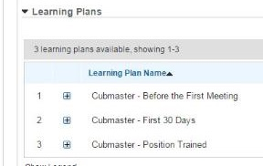

Each of these three parts is broken down into "bite sized" chunks:
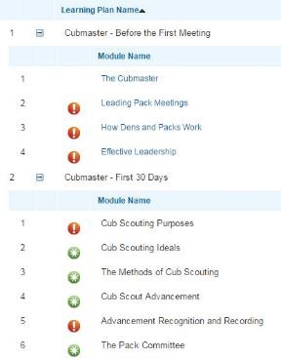
Go check it out and get your
people trained!!!

